Robotic Vision Homework 7

1. Use 'rocks2-l.png' and 'rocks2-r.png' images:

1. Perform stereo matching for the image pair and display the disparity image
2. Follow the instruction in section 14.3.4, reconstruction the 3D scene using the disparity image

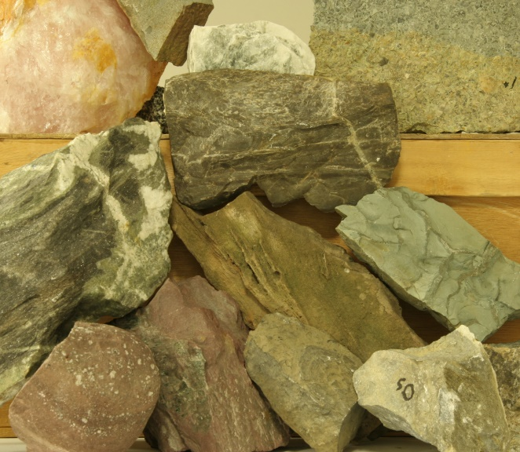 

Hint: your part b result should look similar to this:



**For Python users**, many useful codes can be found online, include this GitHub:

<https://github.com/PHANTOM0122/3D_Reconstruction_with_Stereo>